Using CSGROV
CSGROV (Cylindrical Simulator using GROups and Volumes) is a finite volume solver for the multigroup neutron diffusion equation in cylindrical geometry. It has an associated library of cross sections, allowing it to simulate fast reactor systems with realistic compositions and radial heterogeneity. It is written in MATLAB. This document aims to provide a guide to using the code.
Before running
Before running, you must make sure that CSGROV.m and all associated cross section files are contained in the same folder where you intend to perform the simulations. These cross section files are ‘.mat’ files, with names that must be used in your input (if the given isotopes/mixtures are to be used). The possible isotopes/mixtures are:
bi, c, cr, fe, mo, na, ni, o, pb, steel, zr, am241, b10, np237, pu239, pu240, pu241, th232, u233, u235, u238.
The names are those of either the isotope or the isotopic mixture and should be self-explanatory. Steel is a mixture of isotopes used in steel corresponding to 0.74Fe + 0.18Cr + 0.8Ni by atom.
In principle, a simulation can be performed without all of the cross section library files, provided you do not attempt to use any missing cross sections during the simulation.
Inputs and outputs
CSGROV takes several inputs and produces several outputs. In the MATLAB command line, running CSGROV require all inputs and can produce as many of the outputs as requested. For all outputs, this would look like:
The inputs are contained inside the circular brackets on the right (…). As per common MATLAB use, these do not have to be named as they are written here but the code will assume that the entry in a given position corresponds to a particular variable. The definitions of the input variables are as follows:
R: the outer radius of the reactor in cm.
H: the height of the reactor in cm.
alphaR: the radial albedo of the reactor (dimensionless).
alphaZ: the axial albedo of the reactor (dimensionless).
materialDefs: the definitions of the materials in the reactor.
Each of these is a positive number, other than materialDefs. The input syntax for materialDefs will be described separately.
The outputs of the code are contained in the square brackets on the left […]. As per common MATLAB use, not all of these need to be requested to run the code, e.g., the following is a legitimate syntax:
The definition of the output variables are as follows:
flux: a 3D array of the flux in all energy groups and volumes. The first dimension corresponds to the group number (from fastest to most thermal), the second dimension corresponds to the radial position (from innermost to outermost) and the third dimension corresponds to the axial position (from bottom to top). While the normalization of the flux is arbitrary in eigenvalue problems, it has been normalized to a power density of 300MW/m³ and has dimensions of neutrons/cm²/s.
k: the criticality eigenvalue of the system.
it: the number of iterations required for the solver to converge (it uses a power iteration algorithm).
rbar: a 1D array of volume average radii, corresponding to each radial region from innermost to outermost. The dimensions are in cm.
hbar: a 1D array of volume average heights, corresponding to each axial region from innermost to outermost. The dimensions are in cm.
EB: a 2D array (size 20 by 2) of energy bounds for each energy group, with the first dimension corresponding to the energy group number and the second dimension corresponding to whether the energy is the upper bound (1) or lower bound (2).
There are many ways to visualize the flux in principle. One suggestion is to create a 2D flux array in a given group and then to visualize it using the ‘imagesc’ function. If we wanted to plot the flux in all regions in group 7, for example, we would do the following:
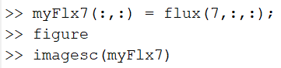
Creating materials
CSGROV can have several radial regions – this is relevant to certain scenarios in modelling fast reactors. We will start with the simple case where the material is homogeneous throughout the reactor. In this case there are at least two properties of materialDefs we must define. The first is:
rmax: the maximum radius at which the material is present in cm (for a homogeneous problem, just make sure that this is larger than R above).
The second property (and possibly additional properties) are the nuclide densities of the material. These are given with a property name corresponding to the particular nuclide/mixture desired (the same as the names of the cross section files), and their value is the atom density in atoms/cm³.
An example of creating a variable which could be used for materialDefs is shown here:
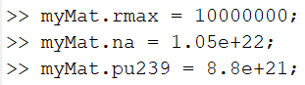
In more general cases, we may want the material composition to vary radially. In such a case we would define materialDefs to be a cell array of the materials above (these are defined using curly braces {…}). Importantly, the rmax value for inner materials should correspond to their radial maximum value, while the outermost material, as before, should have an rmax which is greater than the radius of the problem. An example of this is shown:
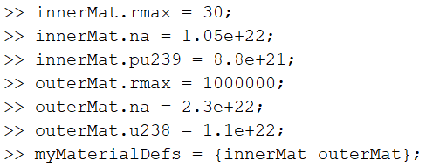
The ordering of the materials in the cell array is irrelevant – the code will sort them by their rmax values.
Running the code
An example of running the code is shown:
